
Faculty

of

Computer

Applications

MCA Sem-1
(AY-2026-27)

Lab Book

Sub Code: 05MC0108 (DBMS)

Enrollment No : | 92600584022
Full Name : | Maheta Kunjal Vijaybhai

Sub.Faculty Name: Dr. Jaypalsinh A. Gohil

Index
Unit : 1 Exercise No | Unit : 1 Definition
1 | Write a PL/SQL block that find  1. Area Of Circle  2. Area Of Rectangle  3. Circumference of Circle
2 | Write a PL/SQL block to accept product name, qty and price from user and then calculate discount in Rs. based on the given (%).
3 | Write a PL/SQL block to calculate the total, percentage and grade of  student based on his/her Rollno from RESULT table. (Create RESULT  table with Rollno, Name, Sub1, Sub2, Sub3, Sub4, Sub5, Total, Per,  Grade attributes with appropriate data type).
4 | 1. Write a program that prints value 1 to 100 numbers using FOR LOOP.  2. Write a program that prints value 1 to 100 number using LOOP  Command.  3. Write a program that prints value 1 to 100 number using WHILE LOOP  Command
5 | Write a PL/SQL block which displays gross salary of employees as per user input EID. (Consider EMP table with EID, EName, Deptno,Deptname Gender, Age, BasicSal) with appropriate data types.) Gross_Salary: BASICSAL + (DA + HRA + Medical) – PF. Rules: HRA = 15% of basic, DA = 50% of basic, Medical = Rs. 500, PF = 10% of basic.
6 | Write a PL/SQL block which accepts measurement in feet and displays it in cm, inch and meter.
7 | Write a PL/SQL block which converts temperature from Celsius to Fahrenheit.
8 | Write a PL/SQL block to delete the record of employee for given EID.
9 | Write a PL/SQL block that calculates the simple interest based on given principal amount, rate of interest and number of years.
10 | Write a PL/SQL block to calculate the square and cube of the given number.

1. Write a PL/SQL block that find:
- Area of Circle
- Area of Rectangle
- Circumference of Circle

/*
Write a PL/SQL block that find
1.Area of circle(pi*radius*radius)
2.Area of Rectangle(length*width)
3.Circumference of circle(2*PI*RADIUS)
*/

ACCEPT CHOICE PROMPT "Enter Your Choice: 1.Area of circle ,2.Area of Rectangle ,3.Circumference of circle "
SET SERVEROUTPUT ON
SET VERIFY OFF
SET FEEDBACK OFF

DECLARE
CHOICE NUMBER:=&CHOICE;
PI NUMBER(7,2):=3.14;
RADIUS NUMBER(5);
LENGTH NUMBER(5);
WIDTH NUMBER(5);
BEGIN
--CHOICE:=&CHOICE;

DBMS_OUTPUT.PUT_LINE(' ');
IF (CHOICE=1) THEN
RADIUS:=&RADIUS;
DBMS_OUTPUT.PUT_LINE('Area of circle is : ' ||PI*(POWER(RADIUS,2)));
ELSIF (CHOICE=2) THEN
LENGTH:=&LENGTH;
WIDTH:=&WIDTH;
DBMS_OUTPUT.PUT_LINE('Area of Rectangle is : ' ||LENGTH*WIDTH);
ELSIF (CHOICE=3) THEN
DBMS_OUTPUT.PUT_LINE('Circumference of circle is : ' ||2*PI*RADIUS);
ELSE
DBMS_OUTPUT.PUT_LINE('Invalid Choice');
END IF;
END;
/
SET SERVEROUTPUT OFF
SET VERIFY ON
SET FEEDBACK ON
Output:

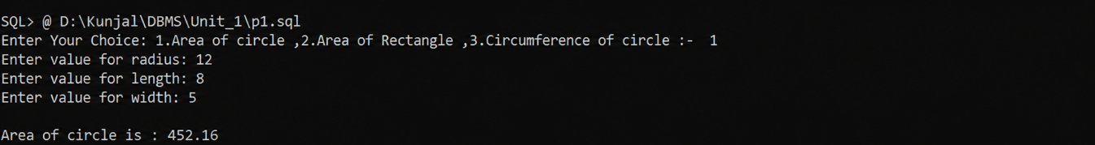

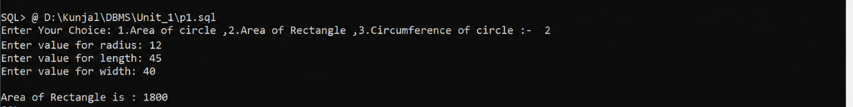

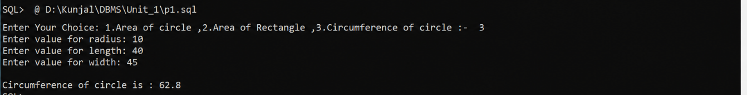

2. Write a PL/SQL block to accept product name, qty and price from user and then calculate discount in Rs. based on the given (%).

/*
Write a PL/SQL block to accept product name ,qty and price from user
and then calculate discount in Rs.based on the given (%)
*/

SET SERVEROUTPUT ON
SET VERIFY OFF
SET FEEDBACK OFF

ACCEPT PN PROMPT "Enter product name :- "
DECLARE
P_NAME VARCHAR(20);
QTY NUMBER(5);
PRICE NUMBER(7,2);
TP NUMBER(7,2);
DISCOUNT NUMBER(5);
FP NUMBER(7,2);
BEGIN
P_NAME:='&PN';
QTY:=&QTY;
PRICE:=&PRICE;
DISCOUNT:=&DISCOUNT;

TP:=PRICE*QTY;
FP:=TP-(TP*DISCOUNT/100);
DBMS_OUTPUT.PUT_LINE(' ');
DBMS_OUTPUT.PUT_LINE('Product name is := '||P_NAME);
DBMS_OUTPUT.PUT_LINE('Total qty is := '||QTY);
DBMS_OUTPUT.PUT_LINE('Price is := '||PRICE);
DBMS_OUTPUT.PUT_LINE('Total Price is := '||TP);
DBMS_OUTPUT.PUT_LINE('Discount is := '||DISCOUNT);
DBMS_OUTPUT.PUT_LINE('Final Price is := '||FP);

END;
/
SET SERVEROUTPUT OFF
SET VERIFY ON
SET FEEDBACK ON

Output:

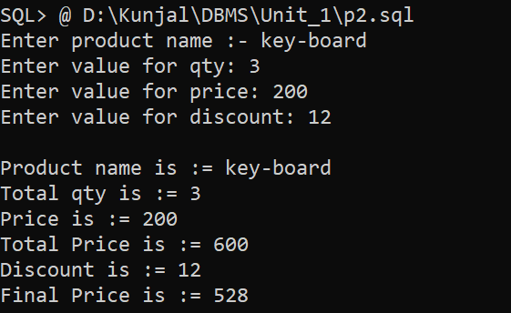

3. Write a PL/SQL block to calculate the total, percentage and grade of student based on his/her Rollno from RESULT table. (Create RESULT table with Rollno, Name, Sub1, Sub2, Sub3, Sub4, Sub5, Total, Per, Grade attributes with appropriate data type).

/*
Write a PL/SQL block to calculate the total, percentage and grade of
student based on his/her Rollno from RESULT table. (Create RESULT
table with Rollno, Name, Sub1, Sub2, Sub3, Sub4, Sub5, Total, Per,
Grade attributes with appropriate data type).
*/

SET SERVEROUTPUT ON
SET VERIFY OFF
SET FEEDBACK OFF
DECLARE
ROLL_NO NUMBER(5);
NAME VARCHAR2(30);
SUB1 NUMBER(3);
SUB2 NUMBER(3);
SUB3 NUMBER(3);
SUB4 NUMBER(3);
SUB5 NUMBER(3);
TOTAL NUMBER(5);
PER NUMBER(7,2);
GRADE VARCHAR2(30);
BEGIN
ROLL_NO:=&ROLL_NO;
NAME:='&NAME';
SUB1:=&SUB1;
SUB2 :=&SUB2 ;
SUB3 :=&SUB3 ;
SUB4:=&SUB4;
SUB5:=&SUB5;
TOTAL:=SUB1+SUB2+SUB3+SUB4+SUB5;
PER:=TOTAL/5;

IF (PER>=75) THEN
GRADE:='O';
ELSIF (PER<=75)AND(PER>=70) THEN
GRADE:='A';
ELSIF (PER<=60)AND(PER>=70) THEN
GRADE:='B';
ELSIF (PER<=50)AND(PER>=60) THEN
GRADE:='C';
ELSE
GRADE:='PASS CLASS';
END IF;

INSERT INTO RESULT(ROLLNO,NAME,SUB1,SUB2,SUB3,SUB4,SUB5,TOTAL,PER,GRADE)VALUES(ROLL_NO,NAME,SUB1,SUB2,SUB3,SUB4,SUB5,TOTAL,PER,GRADE);

DBMS_OUTPUT.PUT_LINE(' ');
DBMS_OUTPUT.PUT_LINE('Roll no:-'||ROLL_NO);
DBMS_OUTPUT.PUT_LINE('Name:-'||NAME);
DBMS_OUTPUT.PUT_LINE(' ');
DBMS_OUTPUT.PUT_LINE('---------------------Result--------------------------');
DBMS_OUTPUT.PUT_LINE('Marks of sub1:-'||SUB1);
DBMS_OUTPUT.PUT_LINE('Marks of sub2:-'||SUB2);
DBMS_OUTPUT.PUT_LINE('Marks of sub3:-'||SUB3);
DBMS_OUTPUT.PUT_LINE('Marks of sub4:-'||SUB4);
DBMS_OUTPUT.PUT_LINE('Marks of sub5:-'||SUB5);

DBMS_OUTPUT.PUT_LINE(' ');
DBMS_OUTPUT.PUT_LINE('-----------------------------------------------');
DBMS_OUTPUT.PUT_LINE('Your total marks : '||TOTAL);
DBMS_OUTPUT.PUT_LINE('Percentage :'||PER||'%');
DBMS_OUTPUT.PUT_LINE('Grade:'||GRADE);
END;
/

SET SERVEROUTPUT OFF
SET VERIFY ON
SET FEEDBACK ON

Output:

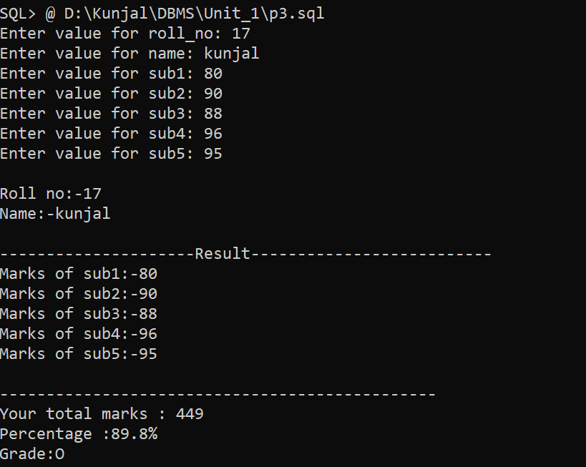

4. 1. Write a program that prints value 1 to 100 numbers using FOR LOOP.
2. Write a program that prints value 1 to 100 number using LOOP
Command.
3. Write a program that prints value 1 to 100 number using WHILE LOOP
Command

/*
1. Write a program that prints value 1 to 100 numbers using FOR LOOP.
2. Write a program that prints value 1 to 100 number using LOOP
Command.
3. Write a program that prints value 1 to 100 number using WHILE LOOP
Command
*/

SET SERVEROUTPUT ON
SET VERIFY OFF
SET FEEDBACK OFF

DECLARE
i NUMBER := 1;
BEGIN

-- FOR LOOP
DBMS_OUTPUT.PUT_LINE('--- FOR LOOP ---');
FOR i IN 1..100 LOOP
DBMS_OUTPUT.PUT(i || ' ');
END LOOP;
DBMS_OUTPUT.PUT_LINE(' ');

-- SIMPLE LOOP
DBMS_OUTPUT.PUT_LINE('--- SIMPLE LOOP ---');
i := 1;
LOOP
DBMS_OUTPUT.PUT(i || ' ');
i := i + 1;
EXIT WHEN i > 100;
END LOOP;
DBMS_OUTPUT.PUT_LINE(' ');
DBMS_OUTPUT.PUT_LINE('--- WHILE LOOP ---');
i := 1;
WHILE i <= 100 LOOP
DBMS_OUTPUT.PUT(i || ' ');
i := i + 1;
END LOOP;
DBMS_OUTPUT.PUT_LINE(' ');
END;
/
SET SERVEROUTPUT OFF
SET VERIFY ON
SET FEEDBACK ON

Output:

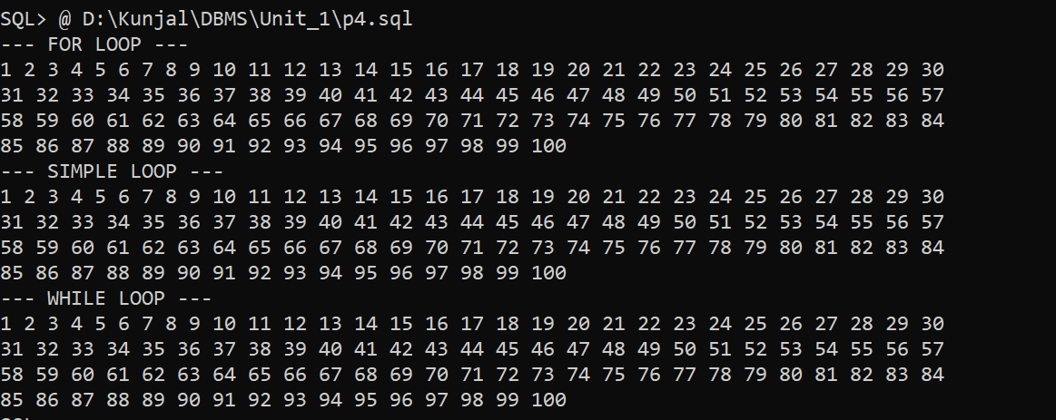

5. Write a PL/SQL block which displays gross salary of employees as per user input EID. (Consider EMP table with EID, EName, Deptno,Deptname Gender, Age, BasicSal) with appropriate data types.) Gross_Salary: BASICSAL + (DA + HRA + Medical) – PF. Rules: HRA = 15% of basic, DA = 50% of basic, Medical = Rs. 500, PF = 10% of basic.

/*
Write a PL/SQL block which displays gross salary of employees as per user input EID.
Consider EMP table with EID, EName, Deptno, Deptname, Gender, Age, BasicSal with appropriate data types.
Gross_Salary:= BASICSAL + (DA + HRA + Medical) – PF.
Rules: HRA = 15% of basic, DA = 50% of basic, Medical = Rs. 500, PF = 10% of basic.
Here for practical we have used Scott users inbuilt EMP table.
*/

SET SERVEROUTPUT ON
SET FEEDBACK OFF
SET VERIFY OFF

DECLARE
V_EID EMP.EID%TYPE;
V_NAME EMP.ENAME%TYPE;
BASIC_SAL EMP.BASICSAL%TYPE;
DA NUMBER;
HRA NUMBER;
MEDICAL NUMBER := 500;
PF NUMBER;
GROSS_SAL NUMBER;

BEGIN
V_EID := &EID;

SELECT ENAME, BASICSAL
INTO V_NAME, BASIC_SAL
FROM EMP
WHERE EID = V_EID;

DA := BASIC_SAL * 0.50;
HRA := BASIC_SAL * 0.15;
PF := BASIC_SAL * 0.10;
GROSS_SAL := BASIC_SAL + DA + HRA + MEDICAL - PF;

DBMS_OUTPUT.PUT_LINE('--------------- SALARY SLIP ---------------');
DBMS_OUTPUT.PUT_LINE('Employee ID : ' || V_EID);
DBMS_OUTPUT.PUT_LINE('Employee Name : ' || V_NAME);
DBMS_OUTPUT.PUT_LINE('Basic Salary : Rs. ' || BASIC_SAL);
DBMS_OUTPUT.PUT_LINE('DA Amount : Rs. ' || DA);
DBMS_OUTPUT.PUT_LINE('HRA Amount : Rs. ' || HRA);
DBMS_OUTPUT.PUT_LINE('Medical Amount : Rs. ' || MEDICAL);
DBMS_OUTPUT.PUT_LINE('Provident Fund : Rs. ' || PF);
DBMS_OUTPUT.PUT_LINE('--------------------------------------------');
DBMS_OUTPUT.PUT_LINE('Gross Salary : Rs. ' || GROSS_SAL);
DBMS_OUTPUT.PUT_LINE('--------------------------------------------');
EXCEPTION
WHEN NO_DATA_FOUND THEN
DBMS_OUTPUT.PUT_LINE(
'Employee record for given EID - ' || V_EID || ' does not exist'
);
END;
/

SET SERVEROUTPUT OFF
SET FEEDBACK ON
SET VERIFY ON

Output:
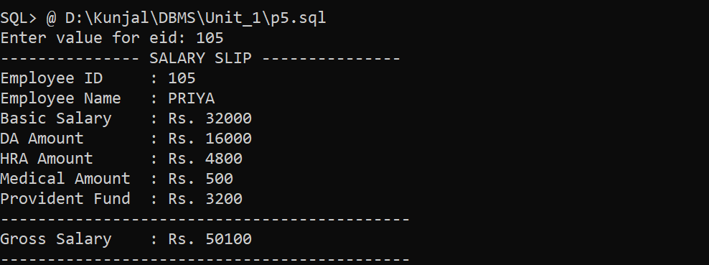
6. Write a PL/SQL block which accepts measurement in feet and displays it in cm, inch and meter.

/*
Write a PL/SQL block which accepts measurement in feet and displays it
in cm, inch and meter.

Formulas:-
1)Inches :-feet * 12
2)Centimeters :- feet * 30.48
3)Meters:-feet*0.3045
*/

SET SERVEROUTPUT ON
SET VERIFY OFF
SET FEEDBACK OFF

DECLARE
FEET NUMBER;
CM NUMBER;
INCH NUMBER;
METER NUMBER;
BEGIN
FEET := &FEET;

CM := FEET * 30.48;
INCH := FEET * 12;
METER := FEET * 0.3048;

DBMS_OUTPUT.PUT_LINE('Feet : ' || FEET);
DBMS_OUTPUT.PUT_LINE('Centimeter : ' || CM);
DBMS_OUTPUT.PUT_LINE('Inch : ' || INCH);
DBMS_OUTPUT.PUT_LINE('Meter : ' || METER);
END;
/

SET SERVEROUTPUT OFF
SET VERIFY ON
SET FEEDBACK ON

Output:
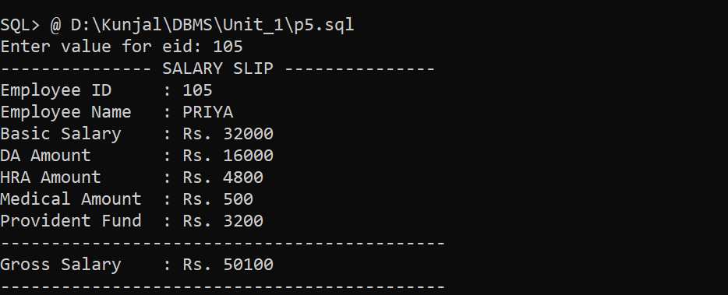

7. Write a PL/SQL block which converts temperature from Celsius to Fahrenheit.

/*
Write a PL/SQL block which converts temperature from Celsius to
Fahrenheit.
Formulas:-
-Celsius to Fahrenheit :-(Celsius *9/2)+32
-Fahrenheit to Celsius :-(Fahrenheit-32)/5/9
*/

SET SERVEROUTPUT ON
SET VERIFY OFF
SET FEEDBACK OFF
ACCEPT CH PROMPT 'Enter your choice :- 1. Celsius to Fahrenheit, 2. Fahrenheit to Celsius: '
DECLARE
CELSIUS NUMBER(10,2);
FAHRENHEIT NUMBER(10,2);
CHOICE NUMBER(10);
BEGIN
CHOICE := &CH;
IF CHOICE = 1 THEN
CELSIUS := &CELSIUS;
FAHRENHEIT := (CELSIUS * 9 / 5) + 32;

DBMS_OUTPUT.PUT_LINE('Value of FAHRENHEIT :- ' || FAHRENHEIT);

ELSIF CHOICE = 2 THEN
FAHRENHEIT := &FAHRENHEIT;
CELSIUS := (FAHRENHEIT - 32) * 5 / 9;
DBMS_OUTPUT.PUT_LINE('Value of CELSIUS :- ' || CELSIUS ||'C');
ELSE
DBMS_OUTPUT.PUT_LINE('INVALID CHOICE... Enter 1 or 2');
END IF;
END;
/

Output:
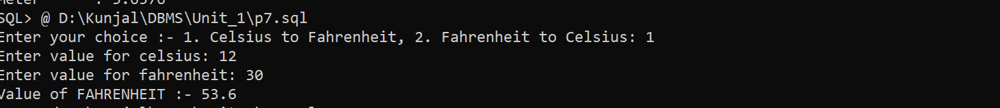

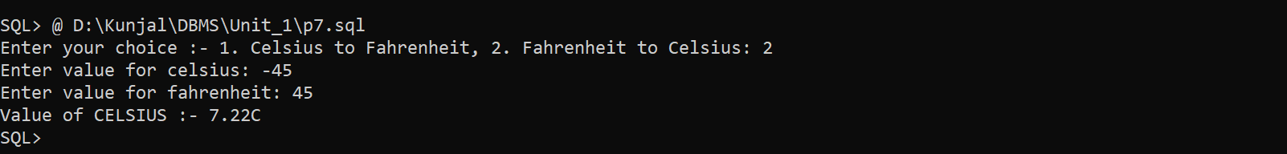

8. Write a PL/SQL block to delete the record of employee for given EID.
/*
Write a PL/SQL block to remove an employee record
for the given Employee ID.
*/

SET SERVEROUTPUT ON
SET FEEDBACK OFF
SET VERIFY OFF
DECLARE
EMP_ID EMP.EID%TYPE;
CNT NUMBER;
BEGIN
EMP_ID := &EID;

SELECT COUNT(*) INTO CNT FROM EMP WHERE EID = EMP_ID;

IF CNT > 0 THEN
DELETE FROM EMP WHERE EID = EMP_ID;

COMMIT;
DBMS_OUTPUT.PUT_LINE( 'Employee ID ' || EMP_ID || ' deleted successfully.' );
ELSE
DBMS_OUTPUT.PUT_LINE('Employee ID ' || EMP_ID || ' does not exist.' );
END IF;

END;
/
SET SERVEROUTPUT OFF
SET FEEDBACK ON
SET VERIFY ON

Output:
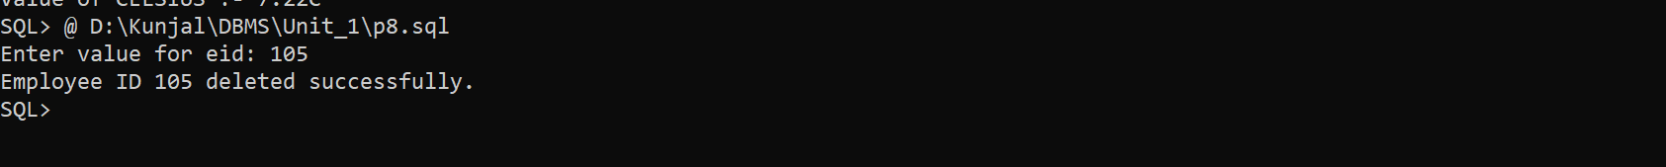

9. Write a PL/SQL block that calculates the simple interest based on given principal amount, rate of interest and number of years.

/* Write a PL/SQL block to calculate Simple Interestand Total Amount. */

SET SERVEROUTPUT ON
SET FEEDBACK OFF
SET VERIFY OFF
DECLARE
P NUMBER;
R NUMBER;
T NUMBER;
SI NUMBER;
AMOUNT NUMBER;
BEGIN
P := &P;
R := &R;
T := &T;
SI := (P * R * T) / 100;
AMOUNT := P + SI;
DBMS_OUTPUT.PUT_LINE('========================');
DBMS_OUTPUT.PUT_LINE('Principal Amount : ' || P);
DBMS_OUTPUT.PUT_LINE('Rate of Interest : ' || R || '%');
DBMS_OUTPUT.PUT_LINE('Number of Years : ' || T);
DBMS_OUTPUT.PUT_LINE('Simple Interest : ' || SI);
DBMS_OUTPUT.PUT_LINE('Total Amount : ' || AMOUNT);
END;
/
SET SERVEROUTPUT OFF
SET FEEDBACK ON
SET VERIFY ON
Output:
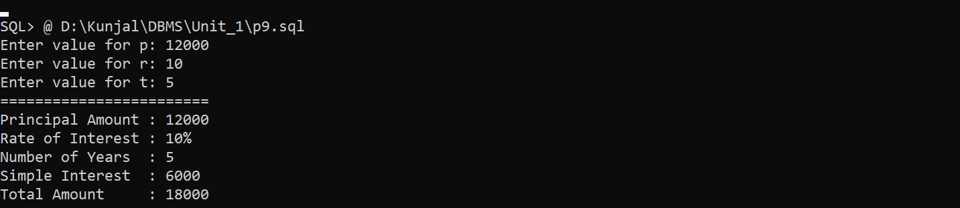

10. Write a PL/SQL block to calculate the square and cube of the given number.

/*
Write a PL/SQL block to calculate the square and cube
of the given number.
*/

SET SERVEROUTPUT ON
SET FEEDBACK OFF
SET VERIFY OFF

DECLARE
N NUMBER;
SQUARE NUMBER;
CUBE NUMBER;
BEGIN
N := &N;
SQUARE := N * N;
CUBE := N * N * N;

DBMS_OUTPUT.PUT_LINE('Given Number : ' || N);
DBMS_OUTPUT.PUT_LINE('Square : ' || SQUARE);
DBMS_OUTPUT.PUT_LINE('Cube : ' || CUBE);

END;
/

SET SERVEROUTPUT OFF
SET FEEDBACK ON
SET VERIFY ON

Output:
